Physics 30H Lesson 39H Special Relativity

# Frames of reference

John Glen was the first American to orbit the Earth in the Mercury spacecraft called *Friendship 7*. He was asked to describe what it felt like to travel at more than 30,000 km/h. He could only answer that he couldn’t tell because there was nothing to measure the speed against. In other words, Glen had no *frame of reference* to make sense of his speed and motion.

Galileo discussed the problem of frames of reference in his study of a falling ball from the masthead of a moving ship. An observer on board the ship will see the ball fall straight down and land in front of the mast. However, an observer on shore will see the ball fall in a parabola due to its vertical acceleration and horizontal velocity. Both observers see what they are expected to see because each observer is in a different frame of reference.

On board observer – moves horizontally with the same velocity as the ball.

On shore observer – the ball and the boat move horizontally past the observer.

Both reference frames – the on board observer and the on shore observer – are referred to as *inertial reference frames*. An inertial reference frame moves at a constant velocity – i.e. constant speed and constant direction. *Non-inertial* reference frames, on the other hand, are frames that are experiencing an acceleration. For example, an observer moving with constant speed in circular motion is experiencing a constant acceleration. His observations of the world will be remarkably different and inconsistent with the observations of an observer in an inertial reference frame. We will be dealing with inertial reference frames alone in this lesson.

But note that there are two unstated assumptions in Galileo’s conception of relativity:

1. *Time is absolute* – time passes at the same rate for observers in different inertial reference frames regardless of their relative motion. Further, an event witnessed by two observers in different inertial reference frames will see the same event at the same time. These events are said to be *simultaneous*.

2. *Space is absolute* – lengths and dimensions do not depend on the relative motion of observers. The length of an object measured by one observer will be the same as the length measured by another observer in a different inertial reference frame.

These assumptions work quite well at common, everyday speeds that are much smaller than the speed of light, however if one observer moves rapidly with respect to another observer, strange things begin to happen…

# Einstein’s thought experiment

As a young man, Albert Einstein knew about Maxwell’s equations for electromagnetic waves and light. However, Einstein asked himself, “What would I see if I rode a light beam?” The answer was that instead of a travelling electromagnetic wave, he would see electric and magnetic fields at rest whose magnitude changed in space but did not change in time. Such fields had never been detected and, further, were not allowed by Maxwell’s theory. He argued that it was therefore unreasonable to think that the speed of light relative to an observer could be reduced to zero. From this it could be concluded that the relative speed of light could not be reduced at all. Based on this argument Einstein proposed two postulates. (A postulate is a presupposition that is accepted as reasonable but without proof.)

First postulate (the relativity principle): All the laws of physics have the same form in all inertial reference frames.

Second postulate (constancy of the speed of light): Light propagates through empty space with a definite speed *c* independent of the speed of the source or the observer.

In a paper written in 1905, Einstein demonstrated how time and length were dependent on the relative motion of the object and the observer.

# Time dilation

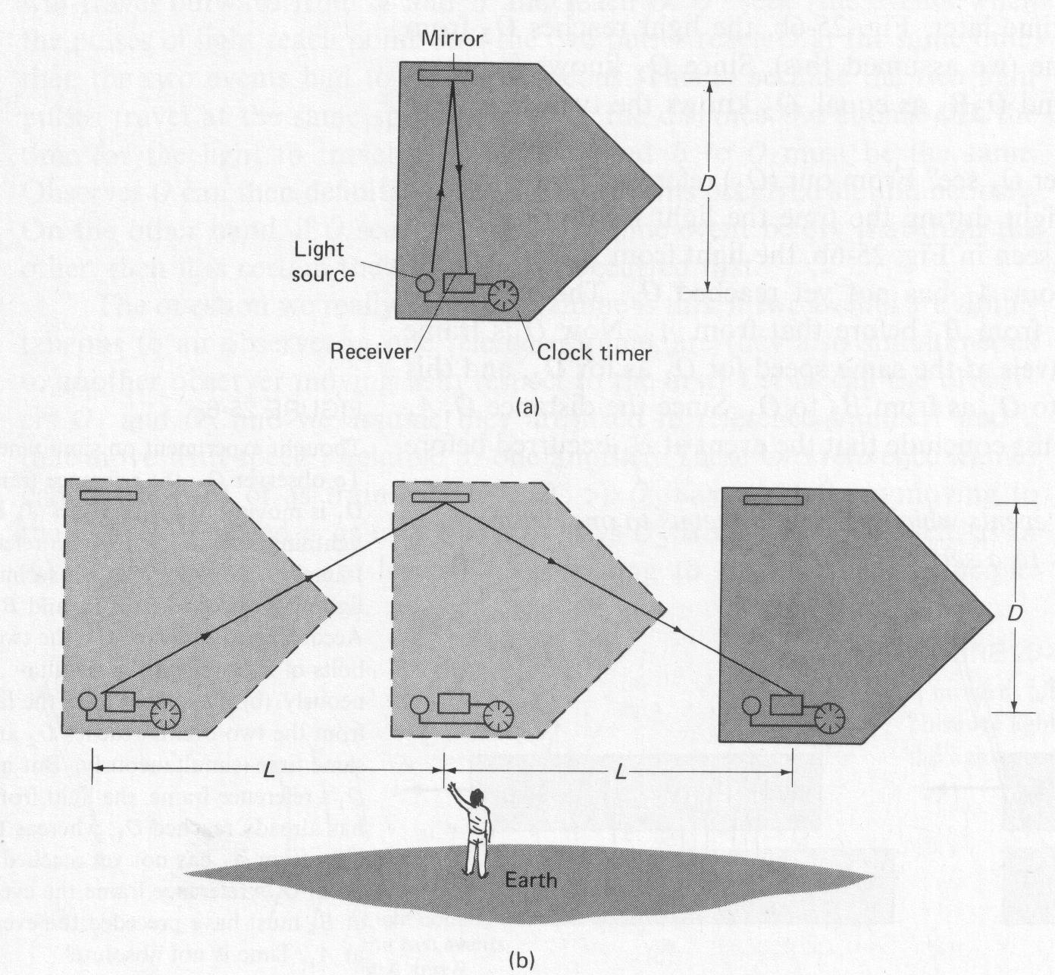When we begin to discuss *special relativity* we are talking about situations where we are moving at speeds near the speed of light. Consider the situation below. The figure shows a spaceship traveling past earth at high speed. The point of view of an observer on the spaceship is shown in (a), and that of an observer on earth in (b). Both observers have accurate clocks. The person on the spaceship (a) flashes a light and measures the time it takes for the light to travel across the spaceship and return after reflecting from a mirror. The light travels a distance 2D at speed *c* so the time required, which we call to, is



The observer on earth, (b), observes the same process. But to this observer, the spaceship is moving; so the light travels the diagonal path shown in going across the spaceship, reflecting off the mirror, and returning to the sender. Although the light travels at the same speed to this observer (i.e. the second postulate), it travels a greater distance. Hence the time required, as measured by the earth observer, will be greater than that measured by the observer on the spaceship. The time interval, t, as observed by the earth observer can be calculated as follows. In the time t, the spaceship travels a distance 2L = v t where v is the speed of the spaceship. Thus, the light travels a total distance on its diagonal path of  and therefore



We square both sides and solve for t to find





We combine this with the formula above for to and find:

 (time dilation equation)

Since the quantity is always less than or equal to 1, we see that t ≥ to . This is a general result of the theory of relativity, and is known as **time dilation**. Stated simply, the time dilation effect says that moving clocks are measured to run slowly. However, we should not think that the clocks are somehow at fault. To the contrary, we assume the clocks are good ones. Time is actually measured to pass more slowly in any moving reference frame as compared to your own. This remarkable result is an inevitable outcome of the two postulates of the theory of relativity.

The concept of time dilation may be hard to accept, for it violates our commonsense understanding. At low speeds like 1000 m/s, the effect is hardly noticeable:

 = to

But at speeds approaching the speed of light, say, v = 0.90 c:

 = 5.26 to

the earth observer sees the clock running 5.26 times slower than the spaceship observer.

When Einstein proposed this theory, there was no way to directly test his idea at the time. However, in 1962 an atomic cesium clock was placed in a jet and the jet flew around the earth non-stop. When the atomic clock was compared to an identical clock on the ground, its time was less than the ground clock by exactly the amount predicted. Additional confirmation is provided by the decay of muons as they enter the Earth’s atmosphere. Muons are subatomic particles with very short life spans before they decay into light energy. The muons that are moving at very high speeds last up to 9 times longer than muons at rest.

Time slows down for moving objects. Biological and mechanical processes will all slow down. A person watching an object move away will see time slow down for the object. In like manner, an observer in the “moving” object looking back at the “stationary” object will see that the stationary object is moving away from it and will see time slow down for the stationary object from his frame of reference.

How long would it take for a space ship to travel 3.0 x 1013 m if it could travel at 0.80 c for an observer on Earth and for an observer in the space ship?

 = **1.25 x 105 s** for the observer on Earth

 = **7.5 x 104 s** for the

observer in the spaceship.

# Length contraction

Just as time is slower for moving objects, the length of an object is measured to be shorter when moving than it is at rest. This is called *length contraction*. The formula:

L = length of moving object



L0 = rest length

which is known as the Lorentz length contraction can be used to calculate the effects of high speeds on length measurements. Note that the only dimension that changes is that which is parallel to the direction of motion—width and depth will not change. In addition, while the outside observer sees an object contract, the inside observer does not see any difference—when length contracts, measuring devices also contract.

A 100 m object at rest, will appear how long when observed at 0.40 c by an outside observer?

 = **91.65 m**

# Mass increase

The three basic mechanical quantities are length, time and mass. The first two have been shown to be relative—their value depends on the reference frame from which they are measured. We might expect that mass, too, is a relative quantity. Einstein showed that the mass of an object increases as its speed increases according to the formula



where mo is the rest mass. Relativistic mass increase has been tested countless times on elementary particles like muons, protons and electrons, and the mass has been found to increase in perfect agreement with the mass-increase equation above.

An electron enters a magnetic field B = 1.5 T perpendicular to the field lines with a speed of 0.50c. What will be the radius of curvature of its path?

 = 1.05 x 10-30 kg

Fm = Fc

q v B = m v2

r

r = m v = 1.05 x 10-30 kg (1.5 x 108 m/s) = **6.6 x 10-4 m**

q B 1.6 x 10-19 C (1.5 T)

A basic result of the special theory of relativity is that no object can equal or exceed the speed of light. As the mass-increase formula shows, as an object is accelerated faster and faster its mass becomes larger and larger. Indeed, if v were to equal c, the denominator in the equation would be zero and the mass would become infinite.



What is the speed of an object if its relativistic mass is three times the rest mass?

 rearranged becomes 

= **2.83 x 108 m/s**

# Relativistic mass and kinetic energy

Einstein was intrigued by the results of J.J. Thomson’s experiment in which the charge to mass ratio (q/m) for the electron began to decrease at very high speeds. Since q wasn’t changing, the mass had to be getting larger. Einstein reasoned that when a force is applied to an object through a distance, work is done and its speed and kinetic energy increases.

W = F x d =  Ek

But as the speed approaches the speed of light (c), the speed can no longer increase. **Note: Speeds above 60% of the speed of light require that relativistic effects must be calculated.** Thus the work done results in an increase of mass.

W = Ek = mc2 where m = m – mo

Ek = (m – mo ) c2

Ek = mc2 – moc2

The second term of the equation above (moc2) is called the *rest energy* of an object. We call mc2 the total energy and we see that the total energy equals the rest energy plus the kinetic energy.

E = mc2

E = moc2 + EK

Here we have Einstein’s famous formula E = mc2 which relates the concept of energy and mass. The equation indicates that mass can be converted to energy and that energy can be converted into mass.

If the kinetic energy of a proton is 6.00 x 10-10 J, what is the proton’s relativistic mass?

Ek = mc2 – moc2



= 1.67 x 10-27kg + 6.67 x 10-27kg

= **8.337 x 10-27 kg**

A pi meson (o) (mass = 2.5 x 10-28 kg) is a subatomic particle which is produced in particle accelerators. It has a very short life span before it is completely converted into a high energy photon of light energy. What is the energy and frequency of the resultant photon in the conversion of a o particle at rest into energy?

= **2.25 x 10-11 J**

f = E/h = (2.25 x 10-11 J)/(6.63 x 10-34 J s) = **3.39 x 1022 Hz**

What is the kinetic energy of a o traveling at 80% of the speed of light.

First, we calculate the relativistic mass m.

 = 4.167 x 10-28 kg

EK = (m - mo)c2 = (4.167 x 10-28 kg - 2.5x 10-28 kg) c2 = 1.67 x 10-28kg(3 x 108m/s)2

EK = **1.5 x 10-11J**

What is the final speed of an electron after it has accelerated through a potential difference of 3.0 MV?

A non-relativistic conservation of energy solution produces the following answer:

Ep = EK

q V = ½ m v2

 = **1.03 x 109 m/s**

But this speed is greater than the speed of light, therefore we have to calculate the speed using relativistic energy. First we calculate the relativistic mass.

EK = 3.0 x 106 eV = 3.0 x 106 (1.60 x 10-19 J/eV) = 4.80 x 10-13 J

Ek = mc2 – moc2 m = (EK – moc2)/c2

 = 4.42 x 10-30 kg

using the rearranged mass-increase equation we get

 = **0.98 c**

v = **2.94 x 108 m/s**

# Hand in Assignment

1. A beam of a certain type of elementary particle travels at a speed of 2.4 x 108 m/s. At this speed, the average lifetime of the particle is measured to be 2.0 x 10-8 s. What is the average lifetime of the particle when it is at rest? (1.2 x 10-8 s)

2. What is the speed of a beam of o particles if their average lifetime is measured to be 3.5 x 10-8 s? At rest, o particles have an average lifetime of 2.6 x 10-8 s.

(2.00 x 108 m/s)

3. A rocket passes you at a speed of 0.80 c. You measure its length to be 90 m. How long would it be at rest? (150 m)

4. A certain star is 20 light years away. A spaceship is travelling at 0.95 c to reach the star from Earth. How long does the trip require as seen from

A. an observer on Earth? (21.05 years)

B. an observer in the spaceship? (6.57 years)

5. What is relativistic mass of a proton accelerated to 60% of the speed of light? (2.09 x 10-27 kg)

6. What is the speed required to create a relativistic mass that is exactly four times the rest mass? (0.968 c)

7. Calculate the rest energy of an electron. (8.20 x 10-14 J)

8. Calculate the kinetic energy of a proton travelling at 2.7 x 108 m/s. (1.95 x 10-10 J)

9. Calculate the energy that could be provided by the complete conversion of a neutron that is travelling at 0.70 c. (2.10 x 10-10 J

 If 0.1% of 1.0 kilogram of uranium completely converts into energy in 0.10 s, what is the average power of the explosion? (9.0 x 1020 W)